EYFS Class Curriculum Overview 2022-2023
TOPICS | Autumn |  |  | Spring |  |  | Summer
 | All about me!  Farmer Duck | Hot and Cold |  | Castles, knights and Dragons | Everything Cornish |  | Jack and the beanstalk | Under the sea
Maple | 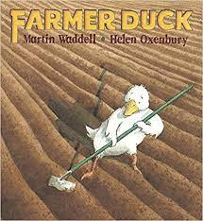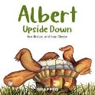 | 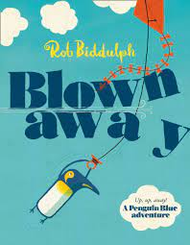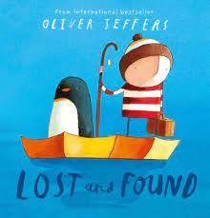 |  | 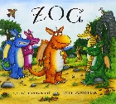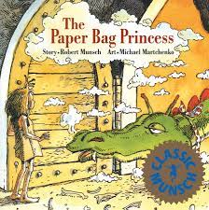 | 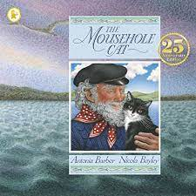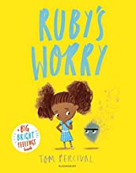 |  | 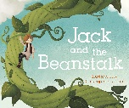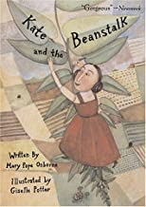 | 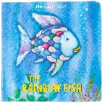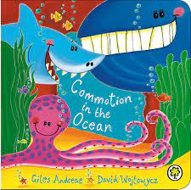
CL and Literacy | RWI phonics – set 1 sounds and begin to blend | RWI phonics – set 1 sounds and sound blending books 1-10 |  | RWI phonics – Photo copy  master 1-20 | RWI phonics – red ditties  Topic based – |  | RWI phonics – green storybooks | RWI phonics – green/purple storybooks
Readers | Introduction to our 20 reads  Farmer Duck | Albert the tortoise stories |  | Zog  The paper bag princess | Mousehole cat |  | Jack and the Beanstalk  And other traditional stories | The rainbow fish  Commotion in the Ocean
Number and SSM | White Rose Autumn SOL |  |  | White Rose Spring SOL |  |  | White Rose Summer SOL
RE | Being special: where do we belong? Harvest Festival | Why is Christmas special for Christians?  Christian - Christmas  Hinduism - Diwali |  | Why is the word ‘God’ so important to Christians? Chinese New Year  Christianity - Pancake day and lent | Why is Easter special to Christians? Christian -  Easter Story  Local Saint- St Piran |  | What places are special and why? | What times/stories are special and why?
Understanding  the World | My Family and where I live  Looking at a map to see where Portreath is in Cornwall.  Pond life  Bugs in our area (snails) | Look at map to show equator and hot and cold countries  Seasons  Investigating materials  Investigating Ice- |  | Talk about their own lives in the past and present  Use a timeline to place important events  Local castles to us | Richard Trevithick/William Murdoch  How School has changed  Locations on a map  Design and make our own flags |  | Contrasting environments inc seasons  Investigating what we need to live | Global warming and our world
PE | Movement and dance  Throwing and catching |  |  | Gymnastics  Multi-skills |  |  | Team games  Multi-skills
Expressive Arts and Design  Inc. Charanga  Music | Draw/paint /Colour mixing and textures, constructing with a purpose |  |  | 3D sculpture and print | Role play and props - Invent and adapt narratives Puppets and models |  |  | Experimenting with colour, design, texture, form and function.
 | ME! | My Stories |  | Everyone | Our World |  | Big Bear Funk | Reflect, review and replay
PSE | New Beginnings | Getting on and falling out |  | Going for goals | Good to be me |  | Relationships | Changes
IT | Logging on to a Chromebook  Coding | Coding  Gooseberry Planet |  | Coding | Coding  Gooseberry Planet |  | Coding | Coding  Gooseberry Planet
Trips | Walk around the village  (Place school on a map and map our walk to Gwel an Mor) |  | Eden project  (place on a map) | Pendennis castle |  |  |  | Beach Trip

Map work (Geography skills)
Investigation (science)
DT-something for someone for a purpose
Year 1 Computing

